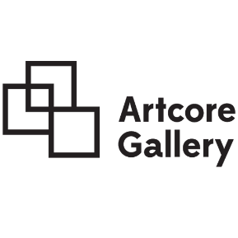
8 Albert Street
Derby DE1 2DS
aisling@artcoreuk.com
www.artcoregallery.org
01332 366 623
Exhibition Proposal Form 2021-22

Name:

Address:

Phone number:

Email:

I / we are interested in (please mark box with Y (YES):

Solo Show
Group show
Other Event

Upstairs Main Gallery Space

 | One week exhibition | £400
 | Two week exhibition | £800
 | Three week exhibition | £1200

Albert Street Downstairs Event Space:
(£50 per hour)

Duration:

For longer exhibitions, please enquire.

Period interested in Exhibiting:
January – March
April – June
July – September
October – December
Flexible

Any specific dates?

Would you be interested in doing an artist talk during your exhibition?
Yes
No

Any addition information / requirements?

Supporting material

- A completed Application Form
- An exhibition proposal outlining ideas and details of the proposed exhibition. This must be no more than 750 words. Please include:
  - Details of the work which will be exhibited (medium, materials, scale)
  - A small blurb about the nature of the show e.g. relevant concepts or themes
- 300 word max artist statement to be provided by each exhibiting artist
- Artist CV to be provided by each exhibiting artist. Please include links to relevant websites and blogs
- Strong images or diagrams of artwork that will be exhibited or work of a similar nature
- This is to be formatted and sent as an inclusive PDF or Word Document containing the information requirements stated above

Please send your application form and supporting material to melanie@artcoreuk.com

